***Deployment of Windows 10 OS using MDT***

What is MDT?

Microsoft Deployment Toolkit is a free software package from Microsoft for automating the deployment of Windows 10, Server 2019 and older windows server and desktop operating systems

**MDT** is one of the most important tools available to IT professionals today.

For that need to install below roles in windows server

1. Active Directory
2. DHCP (Dynamic host configuration protocol): to assign *IP addresses* to the clients
3. WDS (Windows Deployment Services)

Need to download required applications for MDT

You can find the applications in below link:

<https://docs.microsoft.com/en-us/windows-hardware/get-started/adk-install>

1. ADK for windows 10 : To deploy windows 10

Windows Assessment and Deployment Kit (**Windows ADK**), formerly Windows Automated Installation Kit (**Windows AIK or WAIK**), is a collection of tools and technologies produced by Microsoft designed to help deploy Microsoft Windows operating system images to target computers

1. Windows Preinstallation Environment (PE) for Windows 10

Windows PE (WinPE) for Windows 10 is a small operating system used to install, deploy, and repair Windows 10 for desktop editions (Home, Pro, Enterprise, and Education), Windows Server, and other Windows operating systems. From Windows PE, you can: Set up your hard drive before installing Windows

And the third application is **Microsoft Deployment Toolkit(MDT)** which is available in below link

<https://www.microsoft.com/en-us/download/details.aspx?id=54259>

So, Let us start **ADK installation**

Double click on ADK for windows 10 file

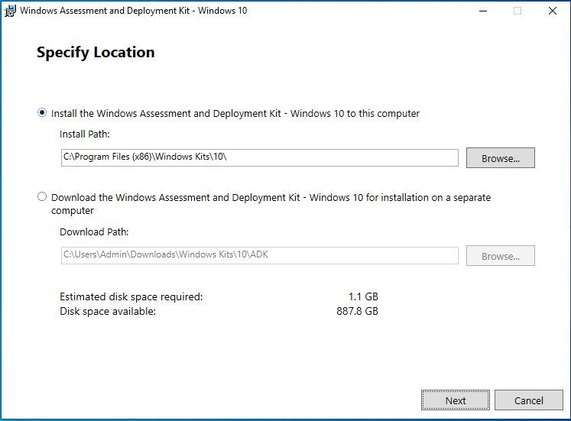

Click on Next.

Select the second option to download files in offline mode.

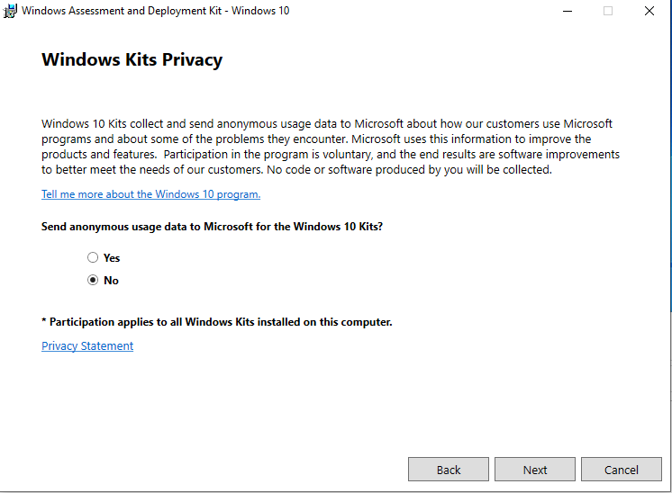

Select no and click on yes.

And accept license and agreement

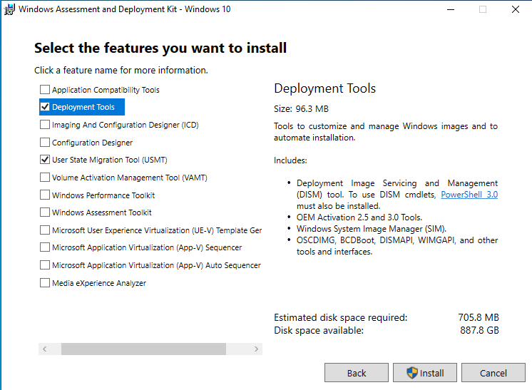

Here select **deployment tools** and **USMT** and click on install

.

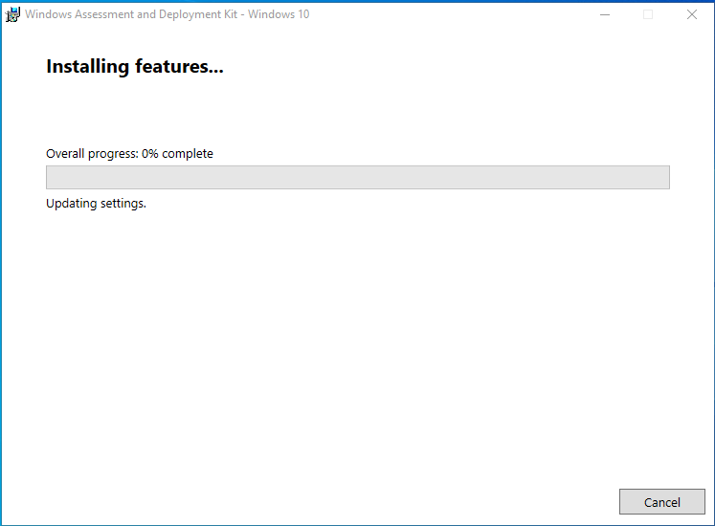

Once it is done 100% click on close.

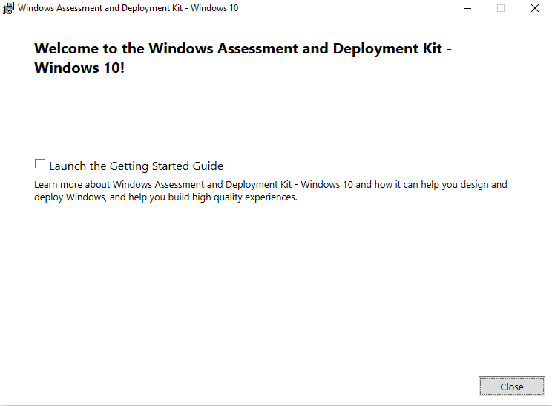

**Windows preinstallation environment(PE) for windows 10 installation:**

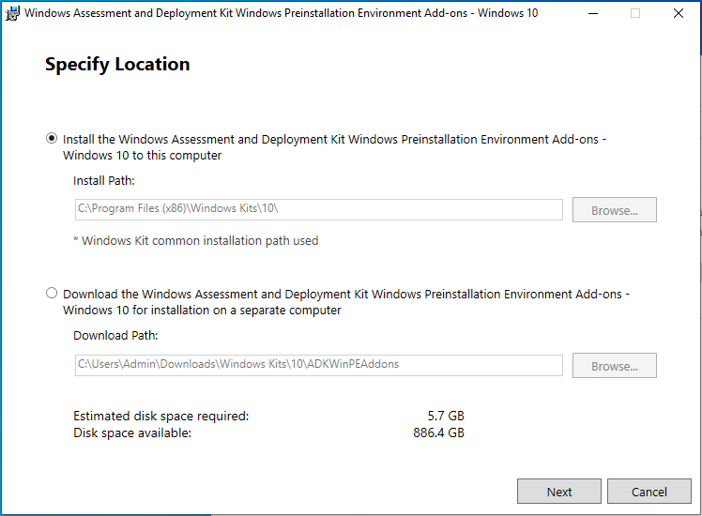

Click on Next.

Select the second option to download files in offline mode.

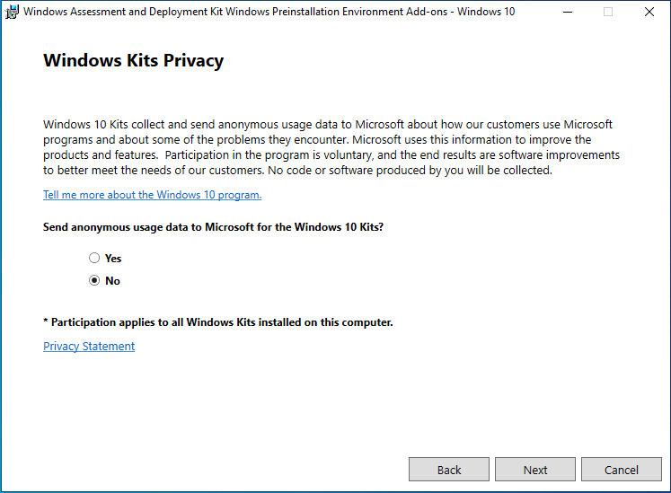

Select no and click on yes.

Accept license and agreement and click on yes

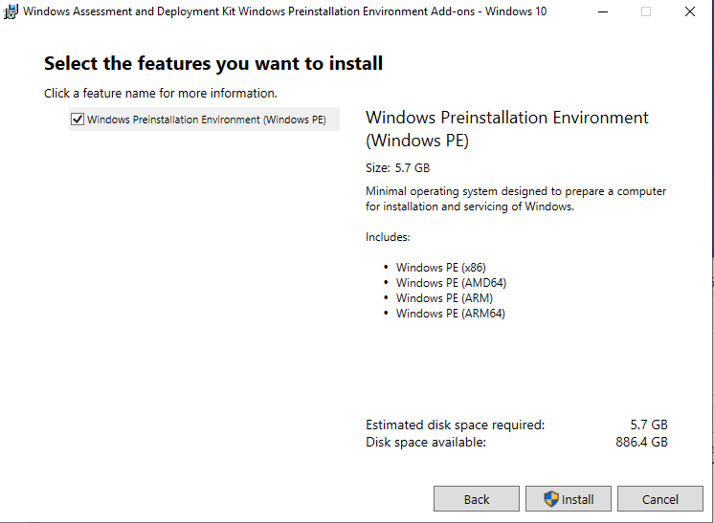

Click on install

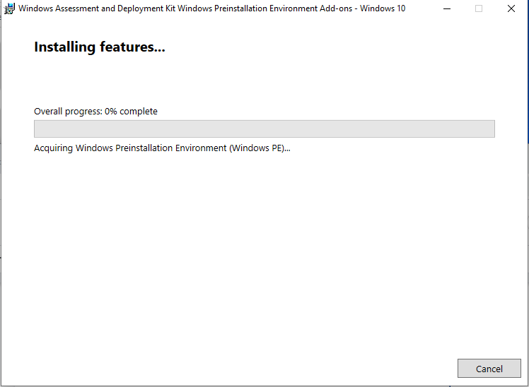

Click on finish once it completes 100%.

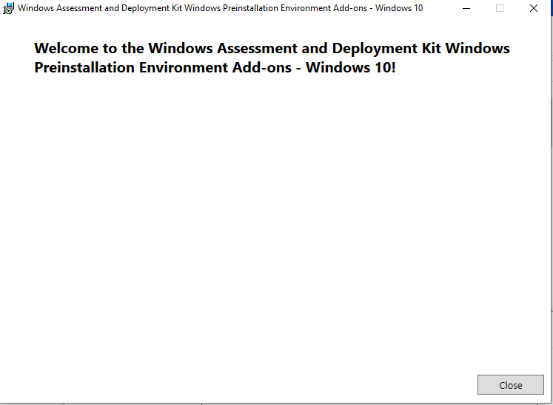

Now Start **MDT** installation:

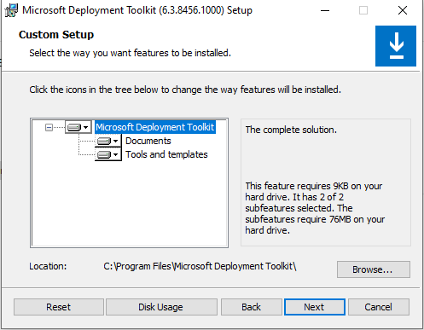

Click on next

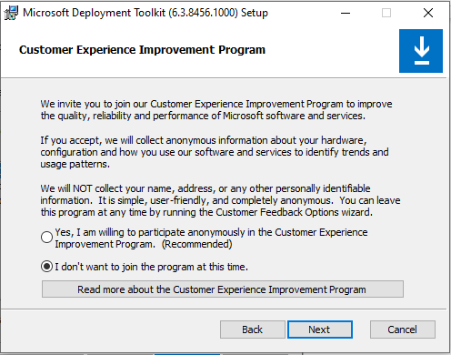

Click on next

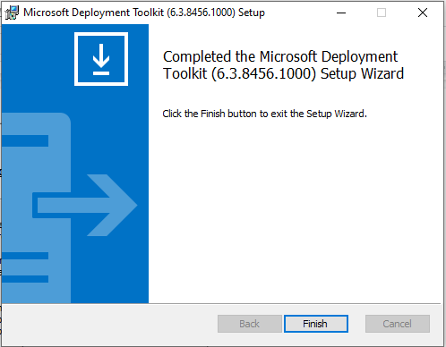

Click on Finish.

Now open Deployment Workbench. We can see the interface of the application.

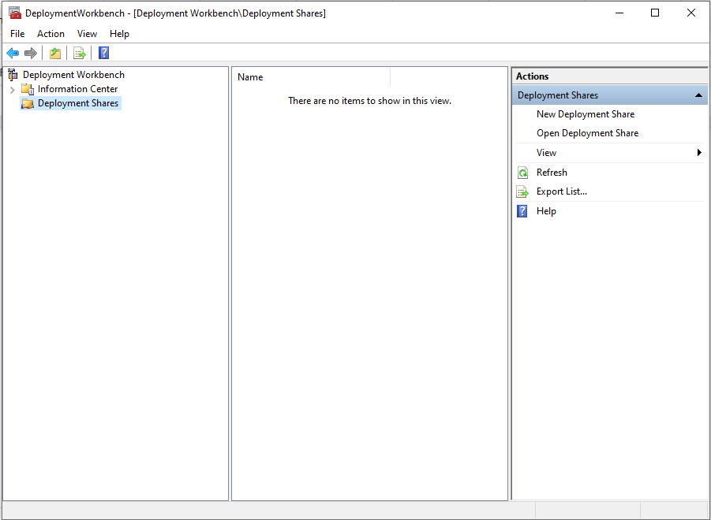

Right click on deployment share and select new deployment share, it will ask path to create shared folders automatically. No need to create folders manually

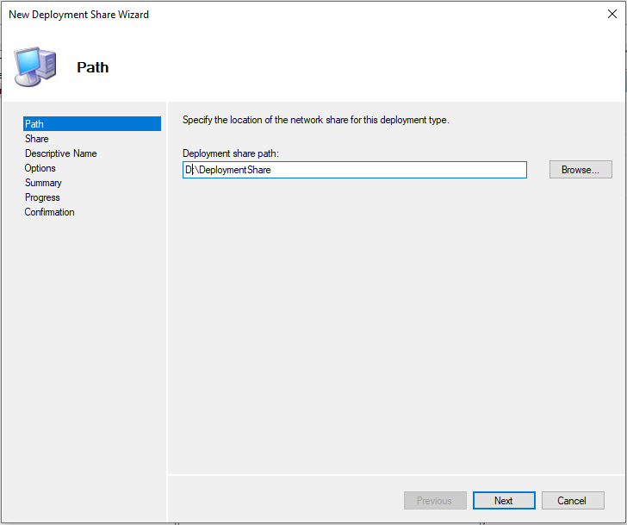

Click on Next

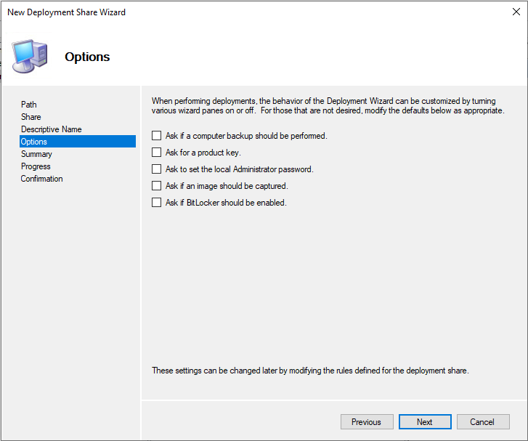

Here deselect all the options and click on next

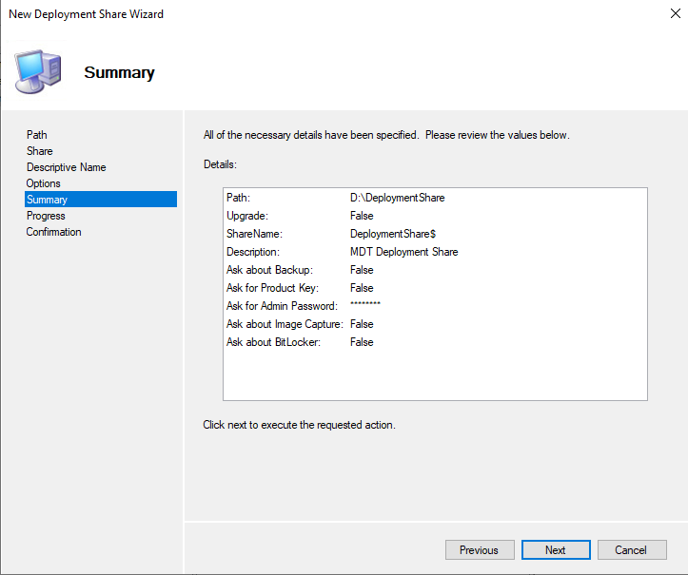

Check the summary once and click on next

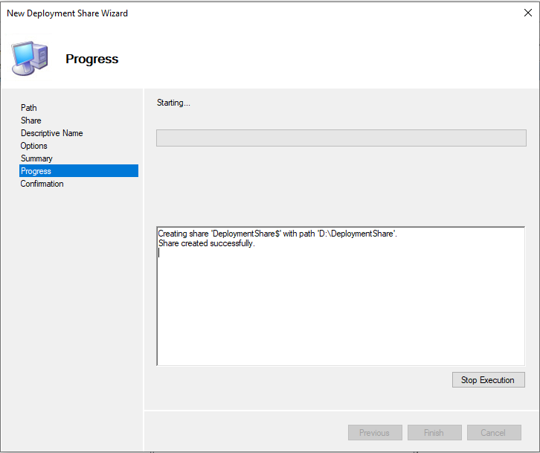

It is creating deployment folders in the desired path once it is done click on finish

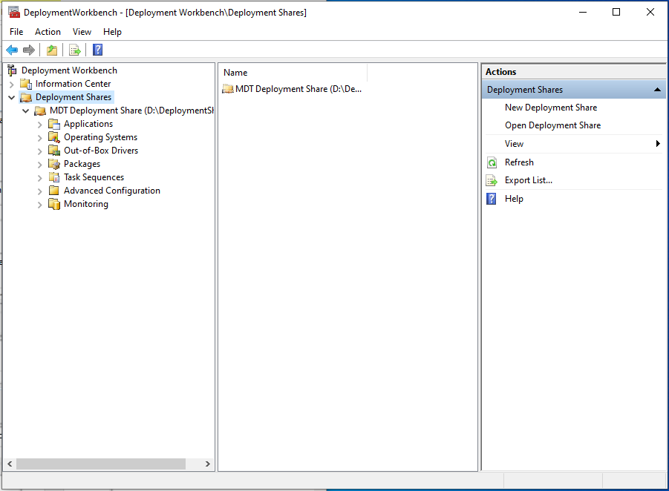

Here you can see all the folders are created and goto to the path “d:\deploymentshare “.

Here, all the folders are created automatically.

Now make it ready “install.wim” file for that

Extract .iso(windows 10 iso) file and goto sources and find install.esd file, copy the file and paste it on desktop

Now open cmd prompt with administrator rights and type following commands

C:\Users\Admin\Desktop>dism /get-wiminfo /wimfile:install.esd

C:\Users\Admin\Desktop>dism /export-image /SourceImageFile:install.esd /SourceIndex:4 /DestinationImageFile:install.wim /Compress:max /Checkintegrity

The above command will create an “install.wim” file. Copy the file into “sources”.

Now open deployment workbench. Click on deployment shares, right click on the operating systems and select import operating system.

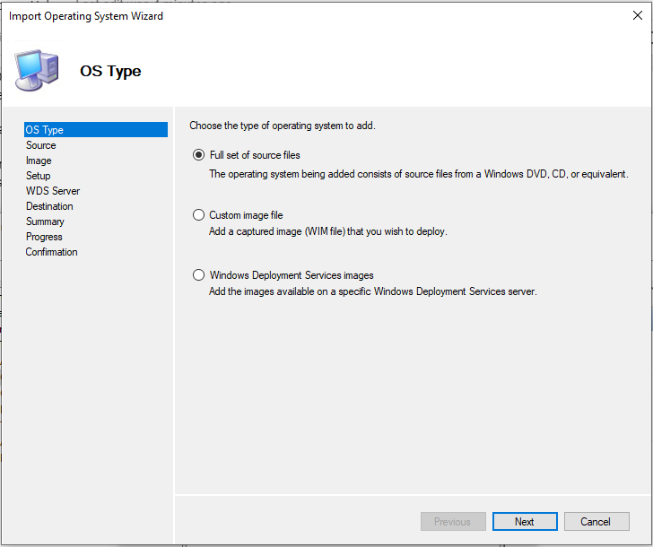

Select full set of source files and click on next

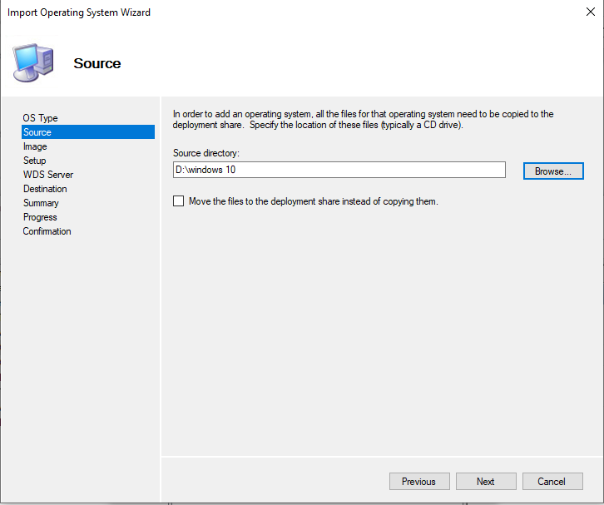

Select windows 10 directory file and click on next

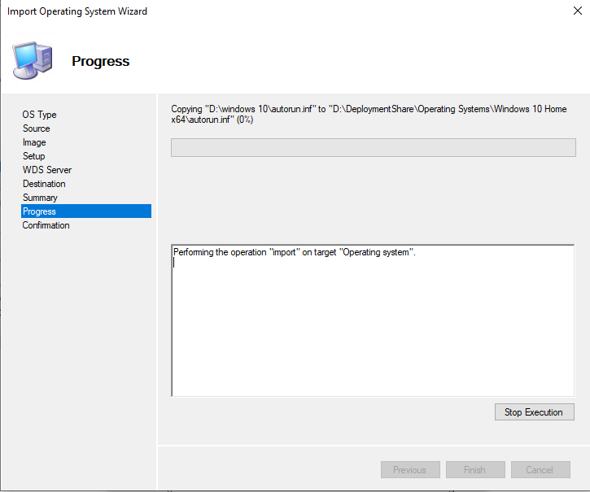

Click on finish, once the progress is completed.

Click on deployment shares and right click on MDT deployment share and update deployment share.

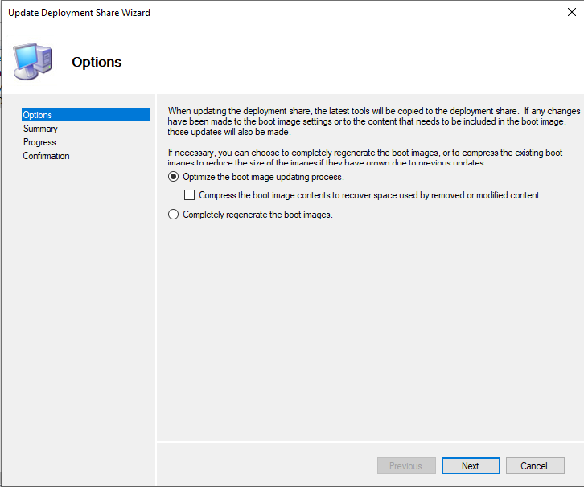

Click on next

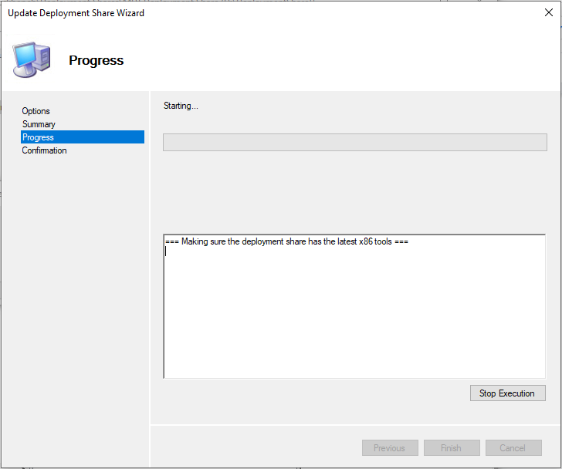

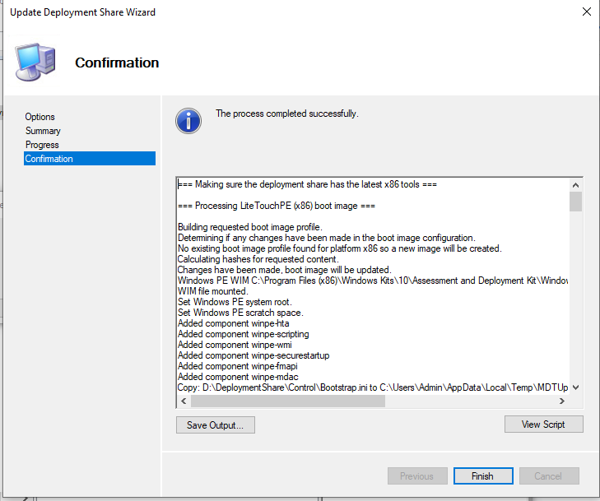

Now create task sequence

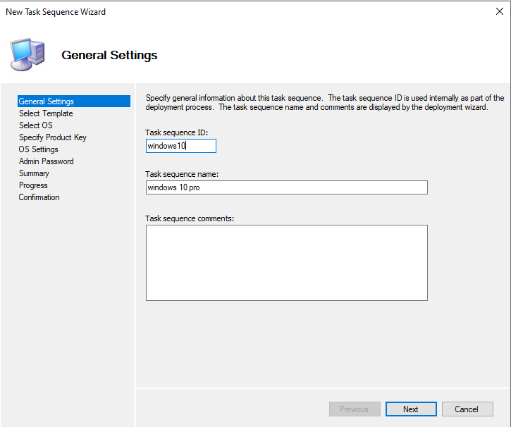

Click on next

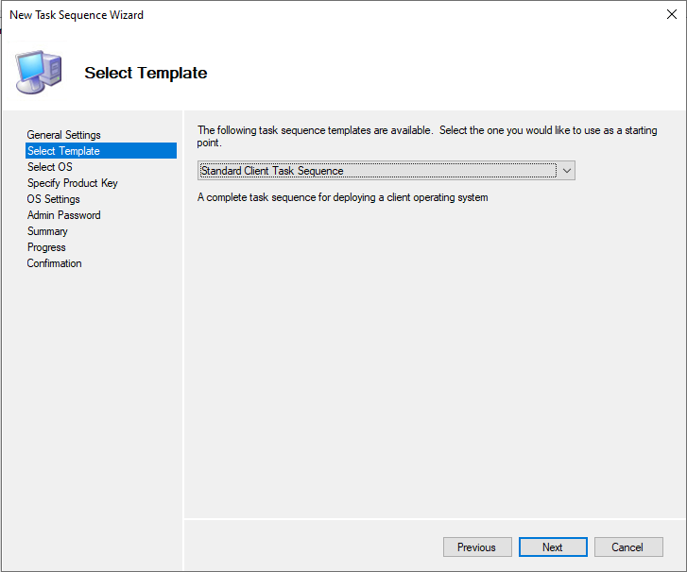

Select “Standard client task sequence” and click on next

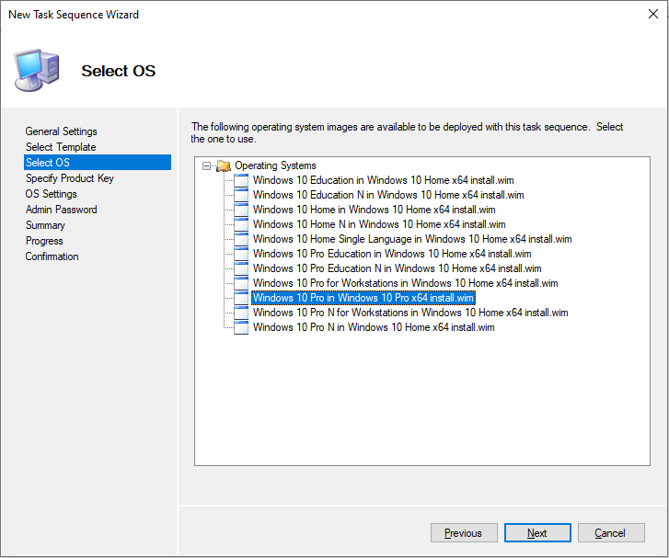

Select OS

Next step choose do not specify a product key at this time and click on next.

Enter organisation name and full name and click on next

Choose Do not specify an administrator password at this time and click on next.

Check the summary and click on finish.

**Now deploy applications after OS installation**.

We can deploy .exe and .msi extension applications.

Goto deployment workbench expand MDT deployment share and right click on applications and select new application. New application wizard will open

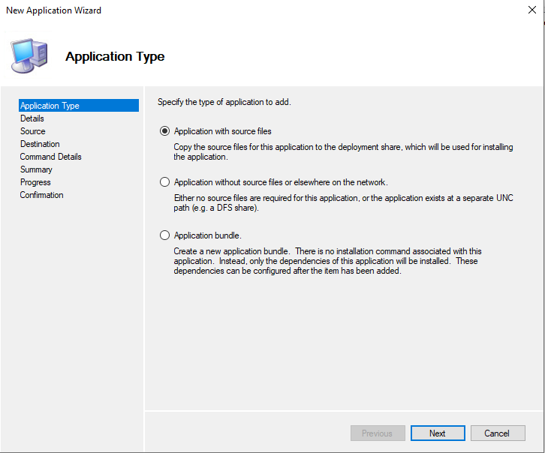

Click on next and give the application name. Here we have given anydesk for example.

And next browse the source directory of the application.

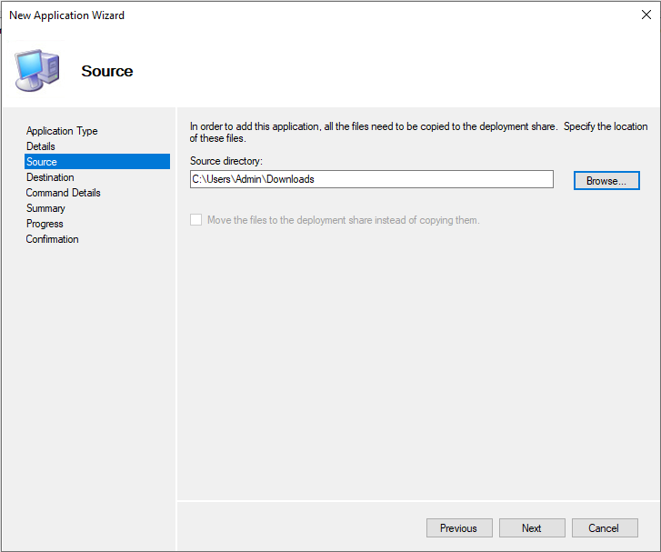

Click on next.

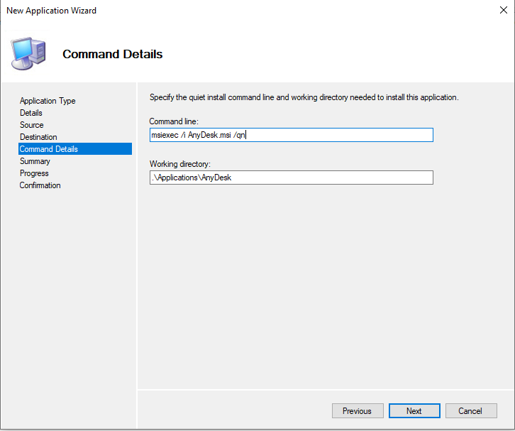

We have to give command line for msi applications

msiexec /i Anydesk.msi /qn

For .exe applications the command line is:

Anydesk.exe /S

Click on next and click on finish.

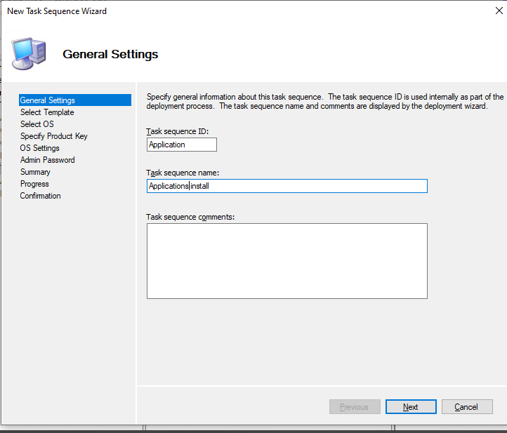

Now create a new task sequence and select “custom task sequence” and click on finish.

Now goto the properties of Application install(task sequence name).

Go to task sequence tab and click on “add” goto general and select install application and browse the application path.

Click on apply.

Now open win 10 properties in task sequences folder, goto task sequences tab.

Delete “install application”.

Goto add, general, run task sequences.

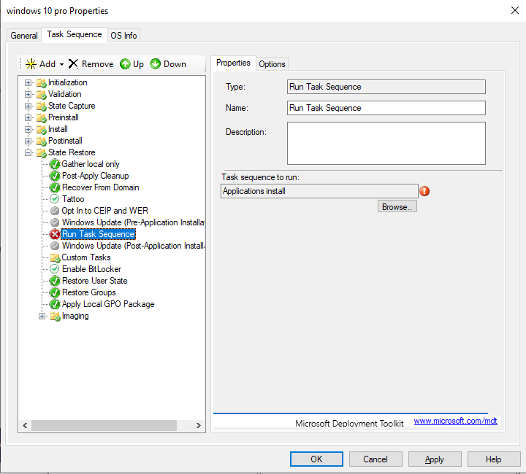

Browse the task sequence to run.

Click on OK.

Open windows deployment services(WDS) right click on boot and add LiteTouchPE_x64.wim

(path:D:\DeploymentShare\Boot\LiteTouchPE_x64.wim)

Now setup is ready.

Go to client pc and

Press F12(for HP laptop) goto bios and enable network boot.

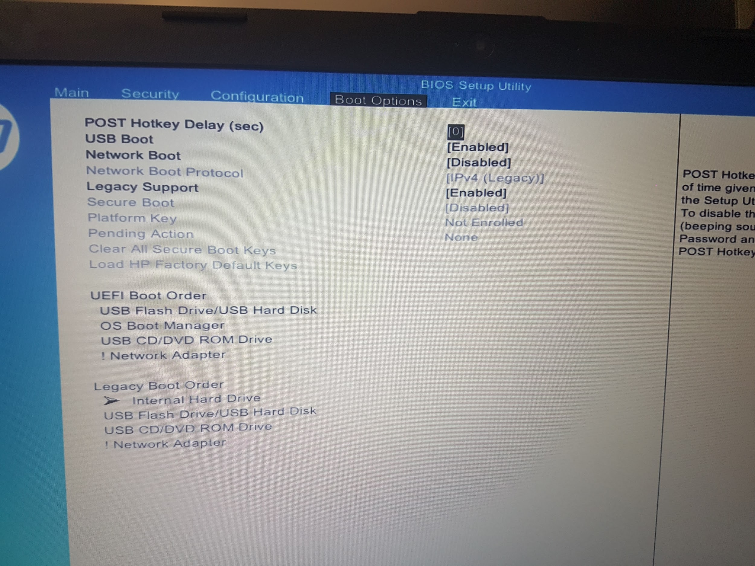

Press f10 for save and exit. Restart your computer and press continuously fp to get boot options.

Select network boot. Client pc gets ip address automatically from DHCP server and starts windows installation process.

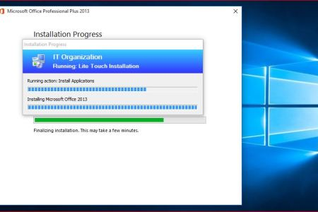

It will ask server credentials to connect with the deployment share folder.

Once the installation is done, applications are also deployed as per the task sequence.

After installation you will get a windows screen.

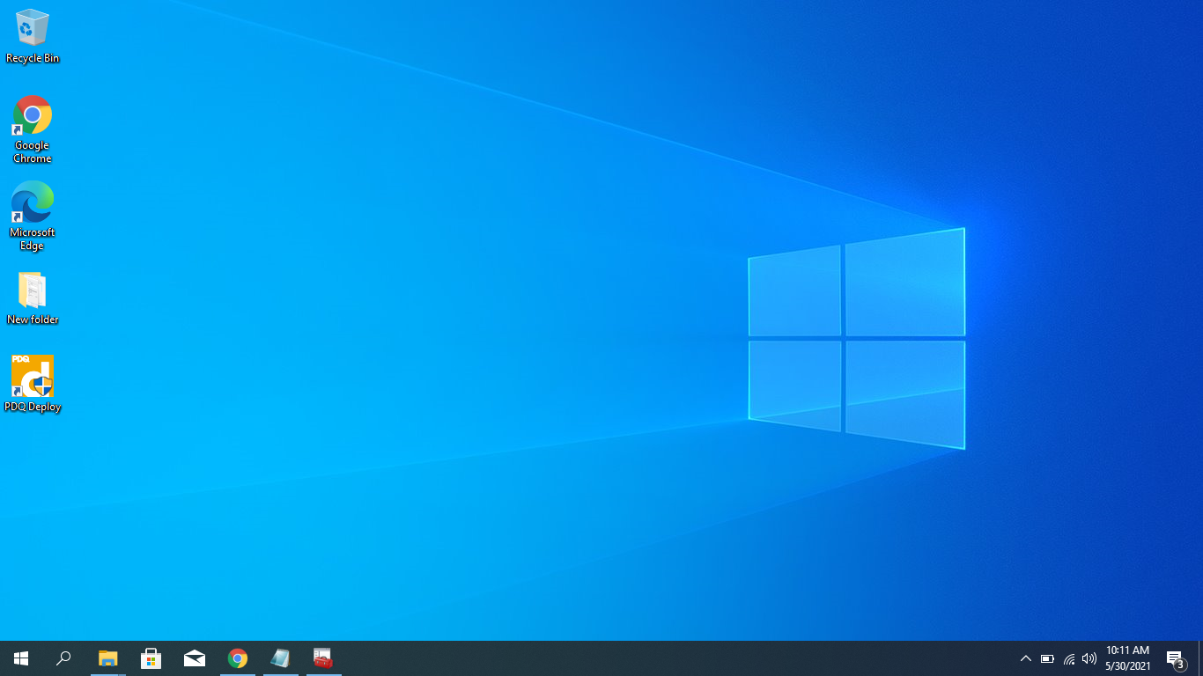

Windows installation is completed using MDT tool kit.